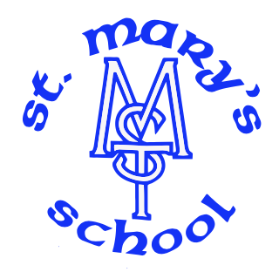

RE: Parents not receiving emails from Arbor.
Dear parents,
There continue to be ongoing issues regarding the receipt of emails from Arbor. This is not localised to our school and is affecting many across the island. It is believed that certain email systems are particularly affected and therefore requires users to give permission to receive emails.
If you have not been receiving the emails from school over the last week, please find below the given instructions which will hopefully resolve the matter.
Recommended Solution (As given by Arbor)
You will need to add school’s domain/address to your Safe Senders list.
How to Add the Address
- Sign in at outlook.live.com or your relevant email system.
- Click the Settings gear icon (top right) → View all Outlook settings.
- Go to Mail > Junk email.
- Under Safe senders and domains, click + Add safe sender.
- Enter the school email address or the full domain (below)
stmarysenquiries@sch.im
- Click OK or Save.
For Parents Using the Outlook Mobile App (iOS or Android)
The Outlook app does not have a direct Safe Senders option. Best solution: Open a browser on your phone, go to outlook.live.com, sign in, and follow the steps above. Changes will sync to the app.
We hope that this will resolve the issues. It can take up to 24 hours once changed to be corrected.
Many thanks,
St Mary’s Team

